Q1:

1 )

EC2:

http://ec2-16-170-233-192.eu-north-1.compute.amazonaws.com:8084/

s3 link:

<https://dkewalramani12.s3.eu-north-1.amazonaws.com/1.png>

2)

a)

1. Create a repository on git

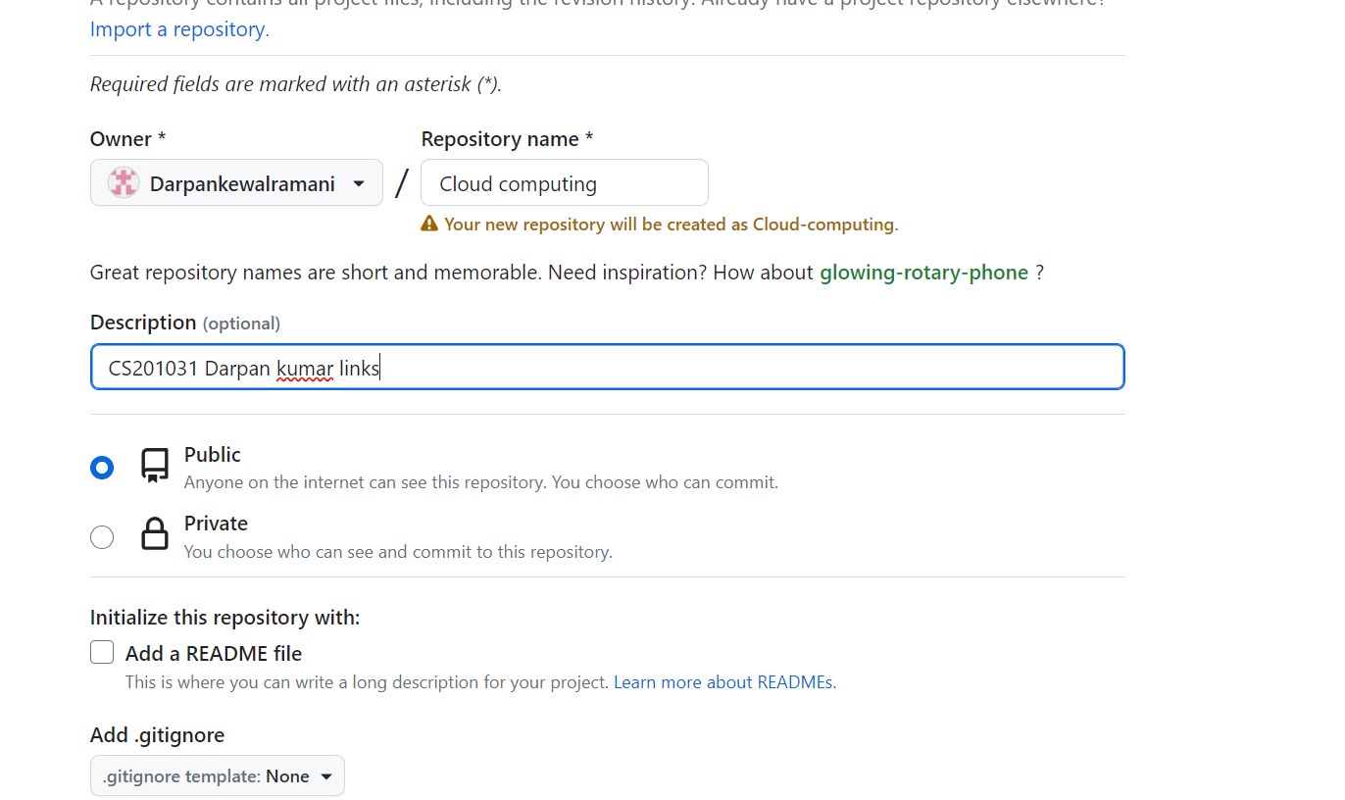

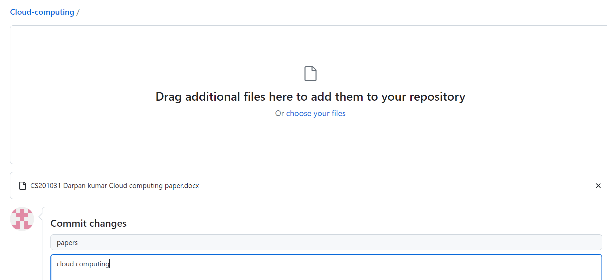

Link:

<https://github.com/Darpankewalramani/Cloud-computing.git>

b)

upload EC2 links:

<http://ec2-16-170-233-192.eu-north-1.compute.amazonaws.com:8084/>

c)

create 2 branch

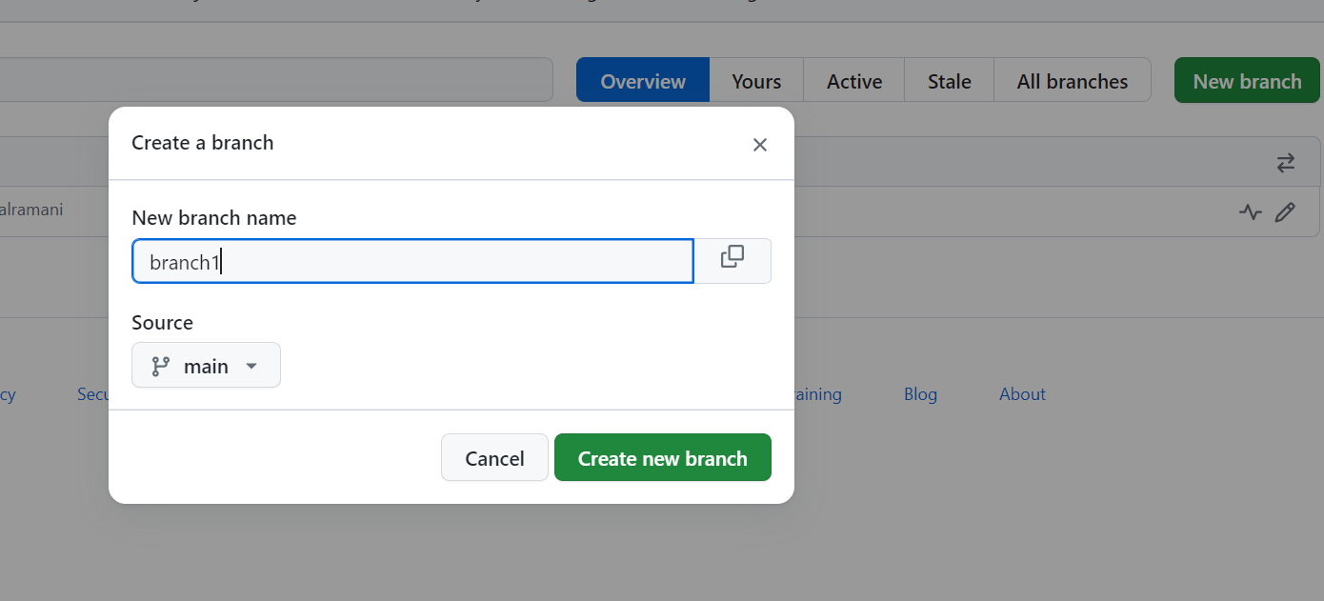

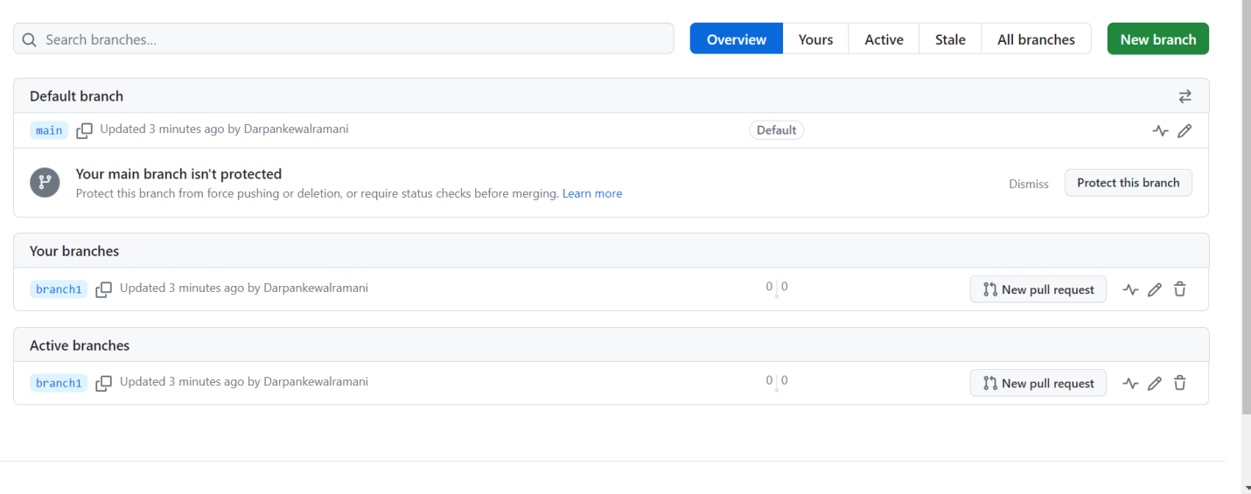

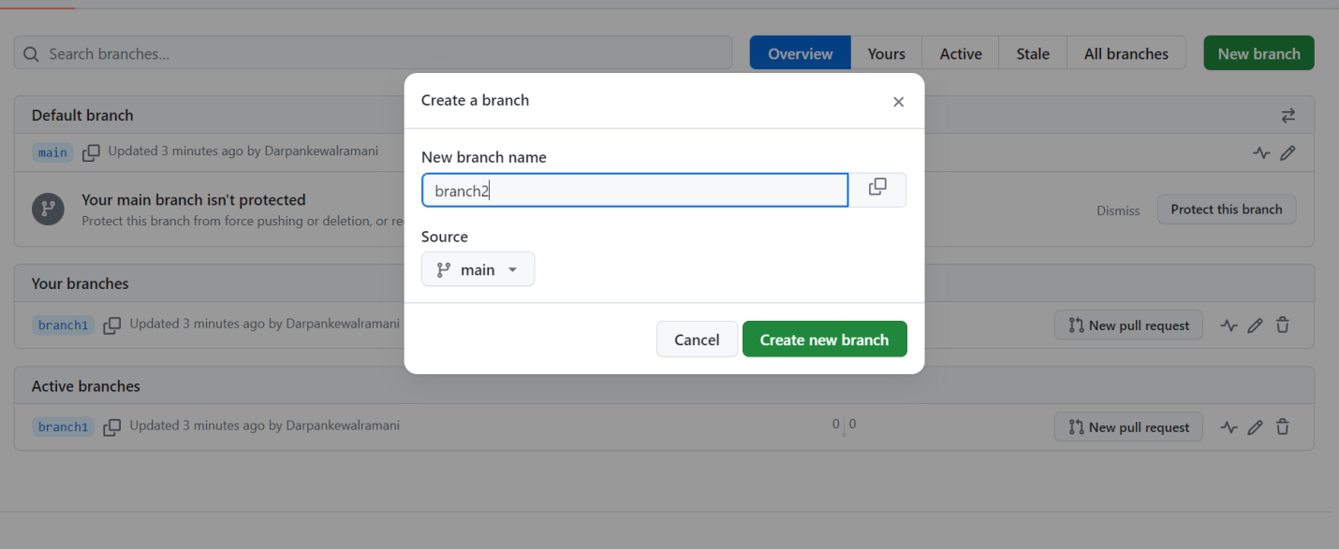

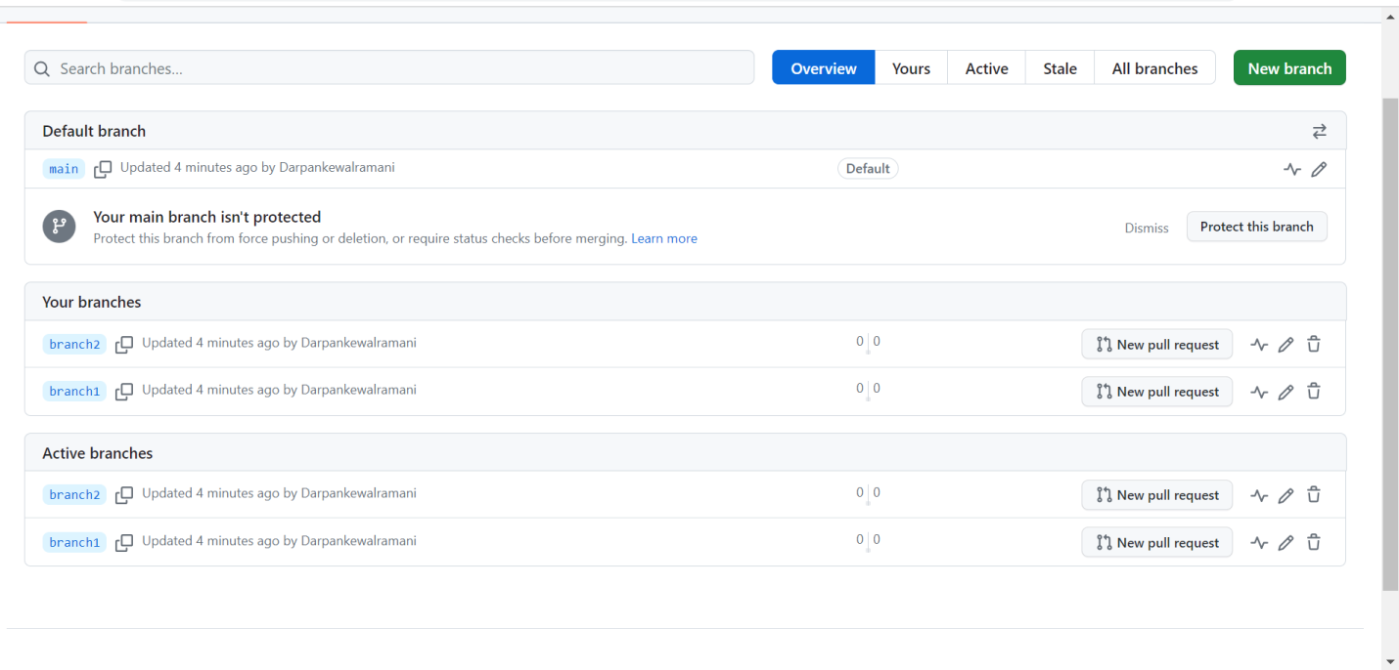

Link:

<https://github.com/Darpankewalramani/Cloud-computing.git>

d) different 2 each branch

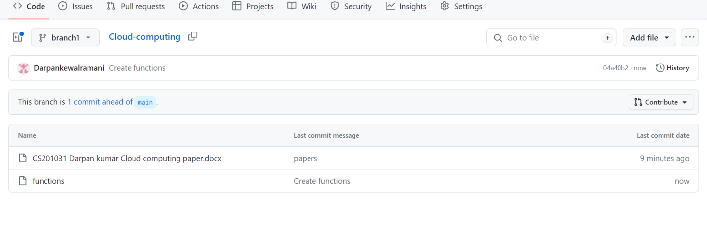

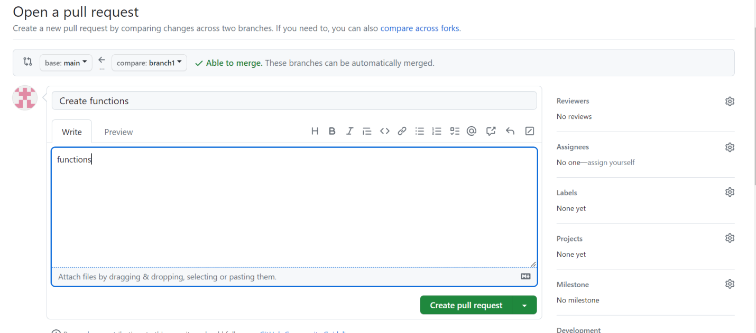

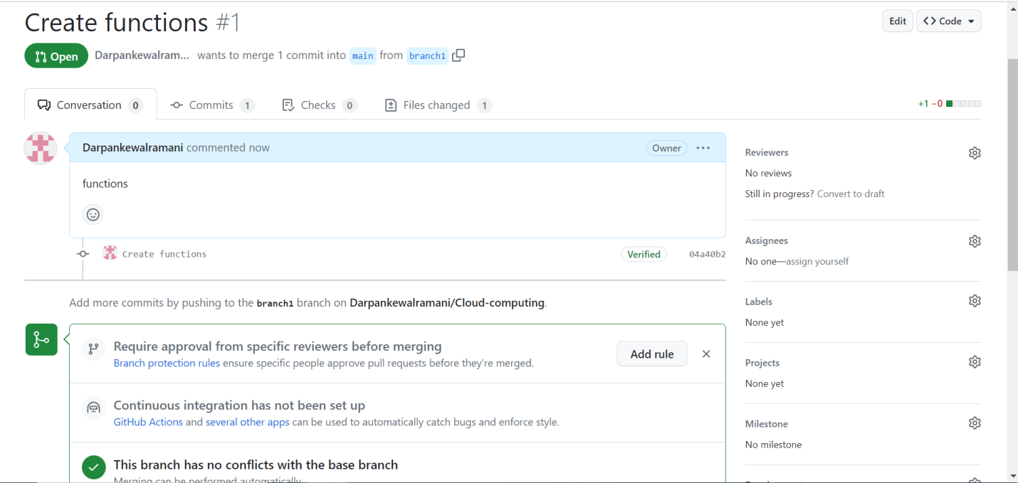

Link:

<https://github.com/Darpankewalramani/Cloud-computing.git>

e) merge 2 branch

command

git merge

f) reverge branch

git reverge

g) merge branch

git merge